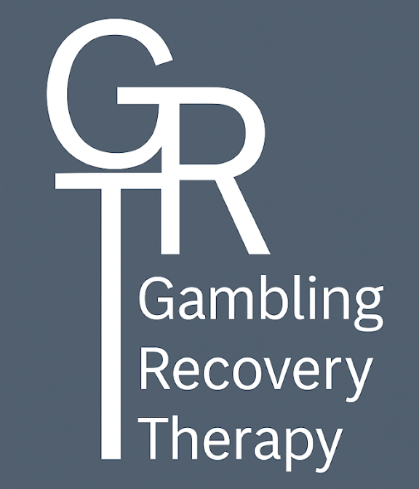
PRIVACY POLICY
This Privacy Policy explains how Claire Jones and Lorraine Perrons collects, uses, and protects your personal information when you use our services. We are committed to safeguarding your privacy in accordance with UK GDPR and the Data Protection Act 2018.
1. What information we collect
We may collect and process the following information:
- Personal details (name, date of birth, email address, phone number).
- Information you share about your gambling history, wellbeing, or related experiences.
- Technical information if you access our website (IP address, browser type, etc.).
2. How we use your information
We use your information to:
- Provide support, resources, and services relevant to gambling recovery.
- Communicate with you (e.g., via email, if you have opted in).
- Personalise resources (e.g., sharing support links relevant to your country).
- Improve our services and client experience.
3. Lawful basis for processing
We process personal information under the lawful basis of consent. For sensitive information (such as health or gambling history), we rely on explicit consent, which you provide when you complete our forms and tick the consent box.
4. How we store your data
- Your information is stored securely using trusted third-party services (such as Google Workspace and Google Forms).
- These providers may process and store data outside the UK or European Economic Area (EEA). Where this occurs, they apply appropriate safeguards in line with GDPR requirements.
- We restrict access to authorised members of our team only.
- We retain your data only for as long as necessary to provide our services, or as required by law.
5. Sharing your data
We will never sell or rent your information. We only share your data if:
- You have given explicit consent, or
- We are required to do so by law.
6. Your rights
You have the right to:
- Access the personal data we hold about you.
- Correct any inaccurate or incomplete data.
- Request deletion of your data (“right to be forgotten”).
- Withdraw your consent at any time.
- Complain to the Information Commissioner’s Office (ICO) if you believe your data has been mishandled.
7. Contact us
If you have any questions about this policy or wish to exercise your rights, please contact:
Claire Jones and Lorraine Perrons
Email: contact@gamblingrecoverytherapy.com

